# **Exercise: Setting Up JUnit**

You need to set up JUnit in your Java project to start writing unit tests.

### **Create a New Java Project**

I created a folder named JUnitDemo and opened it in Visual Studio Code. I ensured the Java Extension Pack was installed.

### **Add JUnit Dependency**

I used Maven to manage dependencies. I created a pom.xml with the following content:

<project xmlns="http://maven.apache.org/POM/4.0.0"  
 xmlns:xsi="http://www.w3.org/2001/XMLSchema-instance"  
 xsi:schemaLocation="http://maven.apache.org/POM/4.0.0  
 http://maven.apache.org/xsd/maven-4.0.0.xsd">  
 <modelVersion>4.0.0</modelVersion>  
  
 <groupId>com.example</groupId>  
 <artifactId>JUnitDemo</artifactId>  
 <version>1.0-SNAPSHOT</version>  
  
 <dependencies>  
 <dependency>  
 <groupId>junit</groupId>  
 <artifactId>junit</artifactId>  
 <version>4.13.2</version>  
 <scope>test</scope>  
 </dependency>  
 </dependencies>  
  
 <build>  
 <sourceDirectory>src/main/java</sourceDirectory>  
 <testSourceDirectory>src/test/java</testSourceDirectory>  
 </build>  
</project>

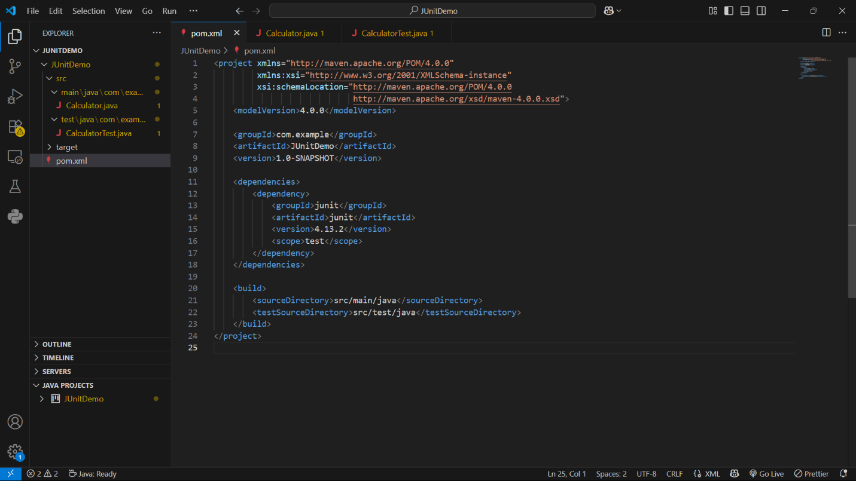

### **Create the Java Class**

I created this file: src/main/java/Calculator.java

public class Calculator {  
 public int add(int a, int b) {  
 return a + b;  
 }  
  
 public int subtract(int a, int b) {  
 return a - b;  
 }  
}

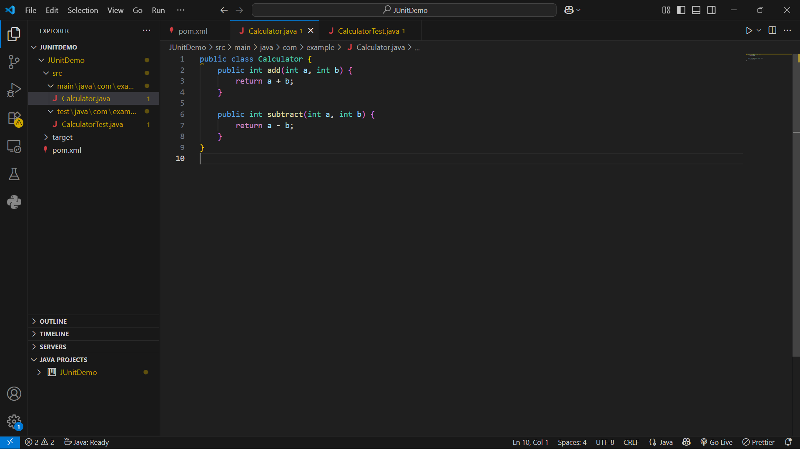

### **Create the Test Class**

I created this file: src/test/java/CalculatorTest.java

import org.junit.Test;  
import static org.junit.Assert.assertEquals;  
  
public class CalculatorTest {  
  
 @Test  
 public void testAdd() {  
 Calculator calc = new Calculator();  
 assertEquals(8, calc.add(5, 3));  
 }  
  
 @Test  
 public void testSubtract() {  
 Calculator calc = new Calculator();  
 assertEquals(6, calc.subtract(10, 4));  
 }  
}

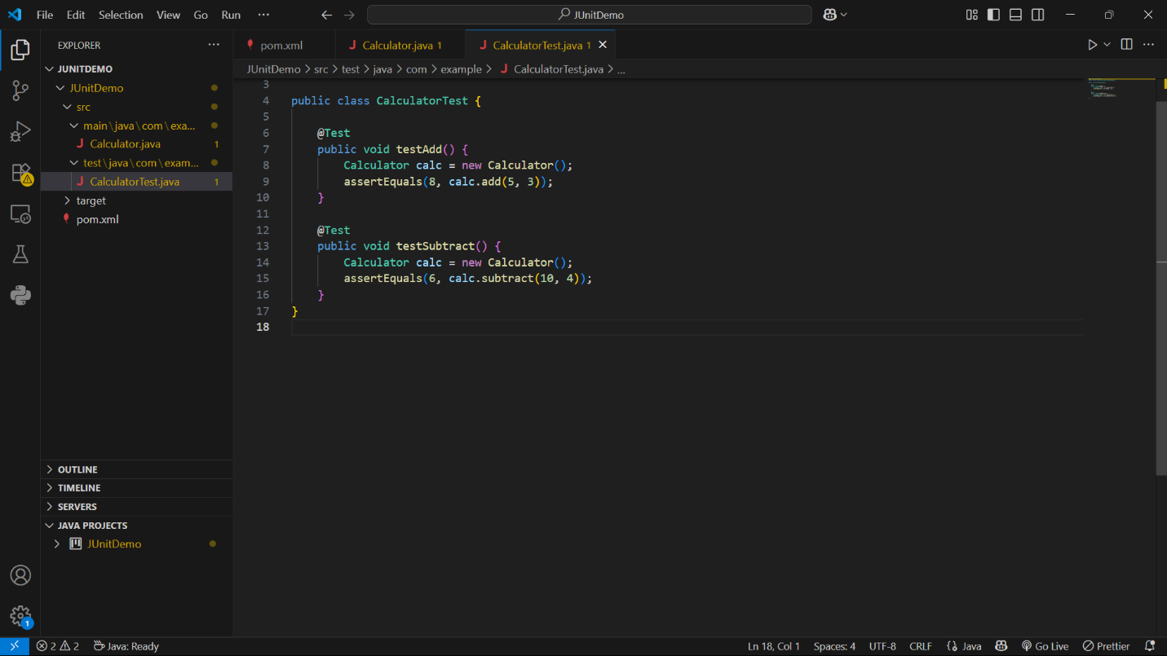

### **Run the Tests**

In the VS Code terminal, I ran:

mvn test

## **Sample Output**

-------------------------------------------------------  
 T E S T S  
-------------------------------------------------------  
Running CalculatorTest  
Tests run: 2, Failures: 0, Errors: 0, Skipped: 0, Time elapsed: 0.005 sec  
  
Results :  
  
Tests run: 2, Failures: 0, Errors: 0, Skipped: 0  
  
[INFO] ------------------------------------------------------------------------  
[INFO] BUILD SUCCESS  
[INFO] ------------------------------------------------------------------------

